SEMICONDUCTING DEVICES
LABWORK :
SIMULATION OF SCHOTTKY DIODE
BY ISSA SIDIBE
27th/10/2023
I. Introduction
Schottky diodes utilize a metal-semiconductor interface to create a rectifying junction, which offers distinct advantages, such as fast switching and low forward voltage drop. In this lab experiment, we explore the characteristics and behavior of Schottky diodes using SILVACO, a powerful simulation tool commonly used in semiconductor device research.
II. Experimentation :

1) Deck build
It is the starting point of each exprimentation with silvaco
It is use to write the script which will define the properties of the material we want to study (dimensions, materials, doping level, etc.)
Main script
go atlas
mes space.mult=1.0
#here we define the dimensions respect to y axe and x axe (12µm x 5µm)
# x from 0 to 12 microns
x.mesh loc= 0.00 spac=0.5
x.mesh loc= 3 spac=0.2
x.mesh loc= 5.00 spac=0.25
x.mesh loc= 7.00 spac=0.25
x.mesh loc= 9.00 spac=0.2
x.mesh loc= 12.00 spac=0.5
#from 0 to 5 microns
y.mesh loc=0.00 spac=0.01
y.mesh loc=1.00 spac=0.01
y.mesh loc=2 spac=0.2
y.mesh loc=5.00 spac=0.4
region num=1 silicon
#definition of the electrodes
electr name=anode x.min=0 length= 12
electr name=cathode bottom
## HERE WE DEFINE THE DIFFERENT DOPOING REGION AND LEVEL (N N for our case)
# definition of the doping region N-epi doping
doping n.type conc=5.0e16
#....N+ doping
doping n.type conc=1.0e20 x.min=0 x.max=12 y.top=2 y.bot=5 uniform
# pour enregistrer la stucture qu'on a defini
save outf=diode_v1.str
model conmob fldmob srh auger bgn print
# Pour definir les differents auxquels on veut acceder
output con.band val.band E.field charge
# below we have defined the work function at 4.97 eV
contact name=anode workf=4.97
method newton
solve init
save outf=diodeex01_0.str
#WE use the function below to show the graphic
tonyplot diodeex01_0.str
#Calcul of the characteristic I(V)
log outfile=diodeex01.log
solve vanode=0 vstep=0.05 vfinal=1 name=anode
tonyplot diodeex01.log
quit

2)Simulation
the script above allow us to obtatin two graphes
Electrical characteristic I(V)

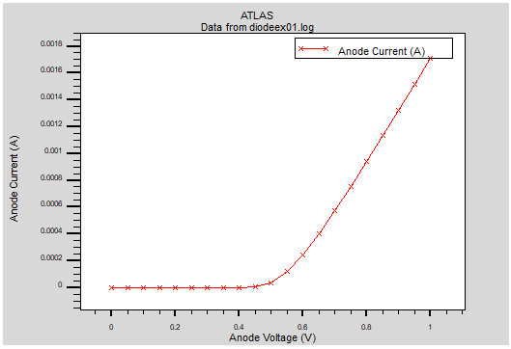

this curve show us the evolution of the current (electrons) versus the voltage we can notice that before 0.6 v the anode current remain fixed at 0 A that is because of the junction region between the 2 levels of doping regions
in other term this barrier is due to the elctric field create between the different concentration level
we need a certain voltage to cancel this electric field and let the electrons flows easily

a. The structure
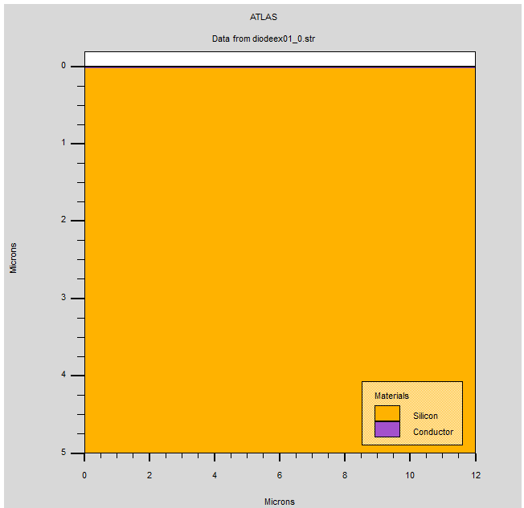
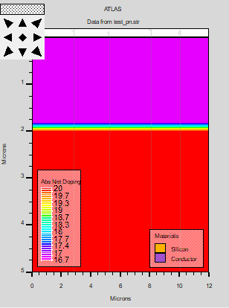

In this picture we can see that the dimension of our material is well respected as we define on the script (12 µm x 5 µm) and also the nature of the material (silicon)

- By doing a cutline (on tools)

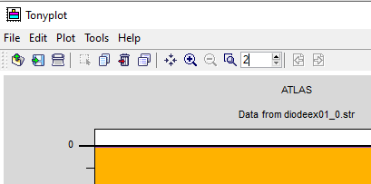

We can display much more properties of the material
From the cutline we can extract more other values
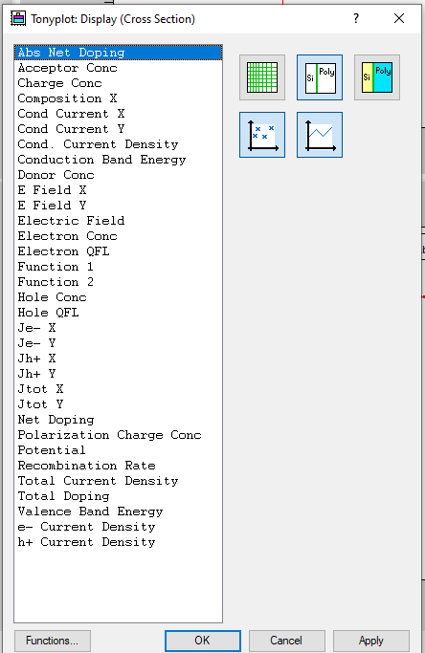

b. Doping level for Vanode= 0 v
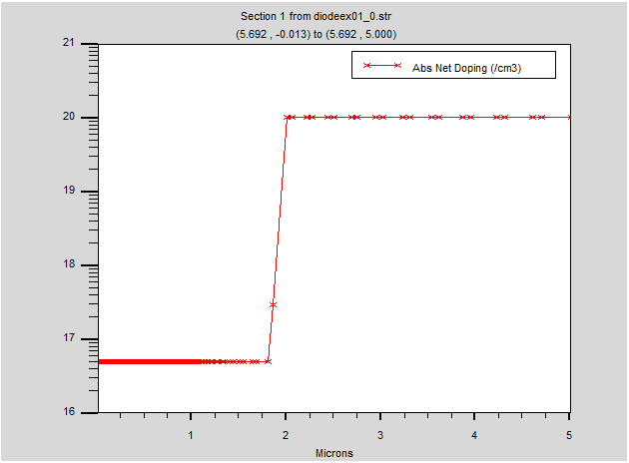

From this picture we can retrieve the doping net per cube cm versus height of the material

c. Concentration and conduction band
for V= 0 v
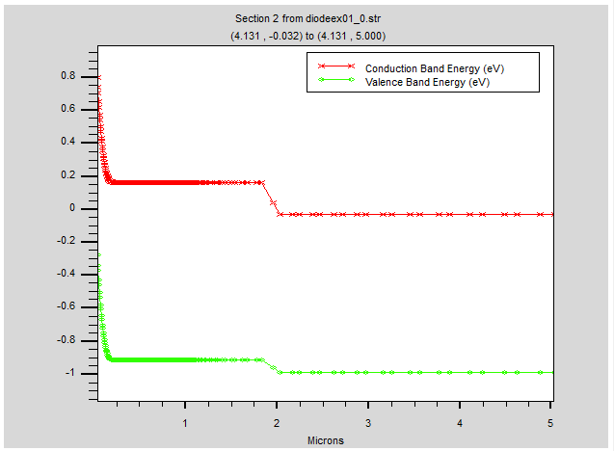
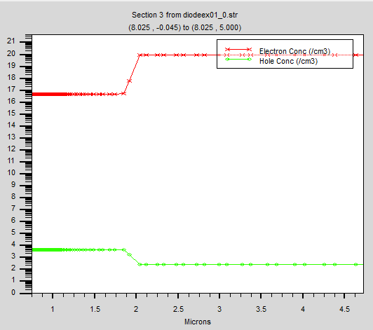

From these two graphes we can see
On the left one we have the conduction band band the valence band
We can notice the junction zone between (1.8µm-2µm)
at 0 µm on the surface the conduction band is at 0.8 eV due to the electric field ; afterward and the energy decrease

On the right one we have the electrons and holes concentration
this one show us what we describe on the script less electron (0-1.8) µm than at (2-5)µm
the inverse case for the holes

d. Potential and Electric field

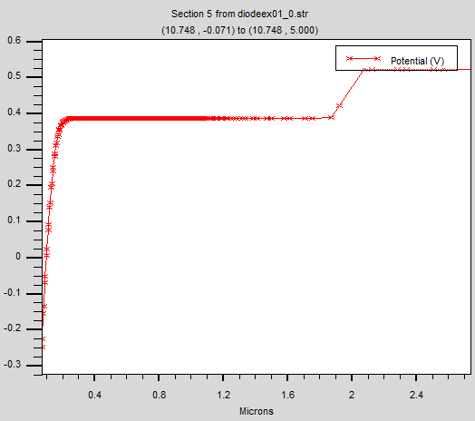
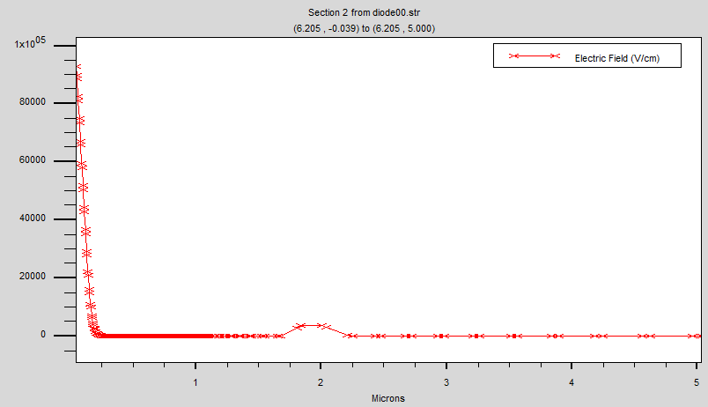

For the Electric field in left we observe a pic ( high E field) around the surface which could be explain by the formation of a barrier on surface of our silicon due to (junction conductor – silicon)
meanwhile the potential is also very low at the surcface
at the surface we have almost 0 electron
3) Biasing of the schottky diodes
If we apply a voltagea certain voltage we bias the device
In order to do so we need to add some line on our previous script
- The new lines
#Simulation with different values of V ANODE
#calcul grandeur Vb à Vg=0
solve vanode=0.0
save outfile=diode00.str
tonyplot diode00.str
#calcul grandeur n,V à 0.9
solve vanode=0.9
save outfile=diode09.str
tonyplot diode09.str
#calcul grandeur n,V à 0.2
solve vanode=0.2
save outfile=diode02.str
tonyplot diode02.str
#calcul grandeur n,V à 0.6
solve vanode=0.6
save outfile=diode06.str
tonyplot diode06.str
quit

4) Simulation for different value of the anode voltage
a. For V= 0.2v
Electric field and potential
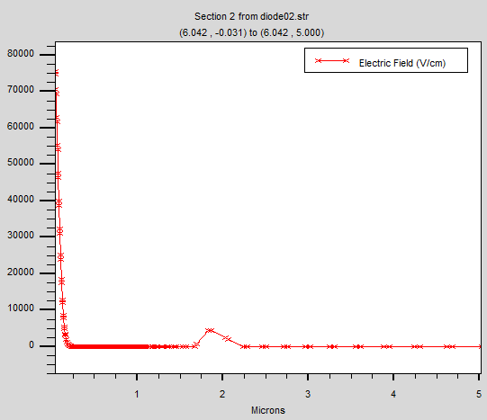
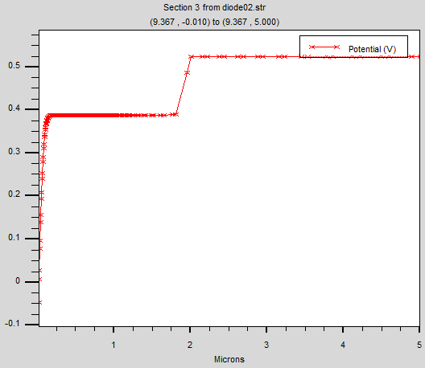

By applying a voltage we observe now a decreasement of the electric field at the surface ; at the same time voltage has also increase ; Now the barrier is more low than at 0V

Doping level and concentration

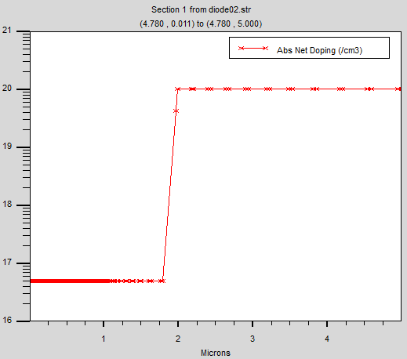
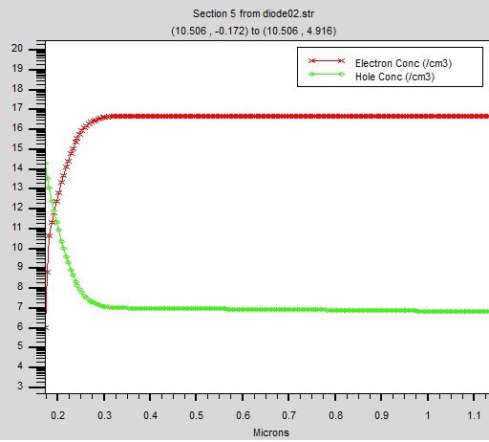

we start to have a higher electron concentration at the surface
NB : the doping level doesn’t depend on the voltage so we observe no change over there

b. For V= 0.6v
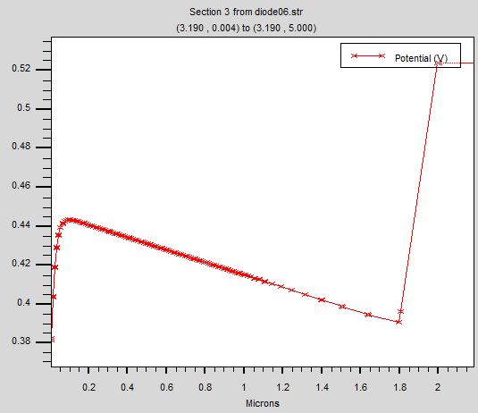
Electric field and potential
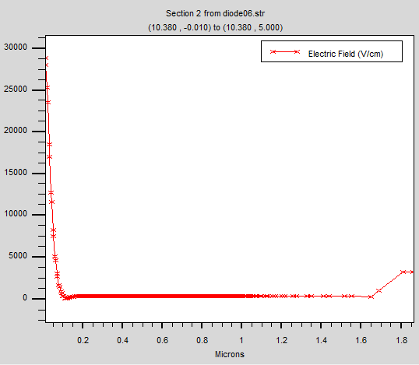

at 0.6 V the Electric field get lower so have some potential on the surface and the concentration of electron get higher
We are at the biasing point electron can move more free now

Concentration
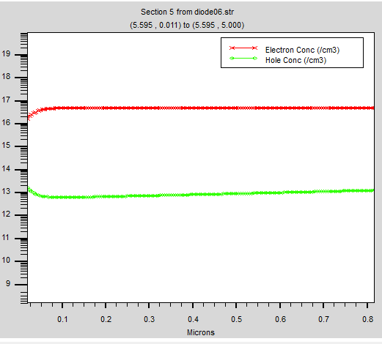

III. Conclusion

In conclusion, these studies show us the properties of schottky diodes and also the schottky contact between the silicon and the conductor which represent the metal.
Our exploration of Schottky diodes through SILVACO simulations has provided valuable insights into their characteristics and performance. We have observed the advantages of low forward voltage drop

